**Lab Exercise #7**

**Name:** Josiah Joed G. Getes **Date:** 08/23/2021

**Class:** CSci 14 – G003

**Objectives:** To pass an array into a function and initialize or process its content.

To implement a Fibonacci sequence generator in order to check if an input value is a Fibonacci number or not.

To count the number of Fibonacci numbers in an array.

**CODE:**

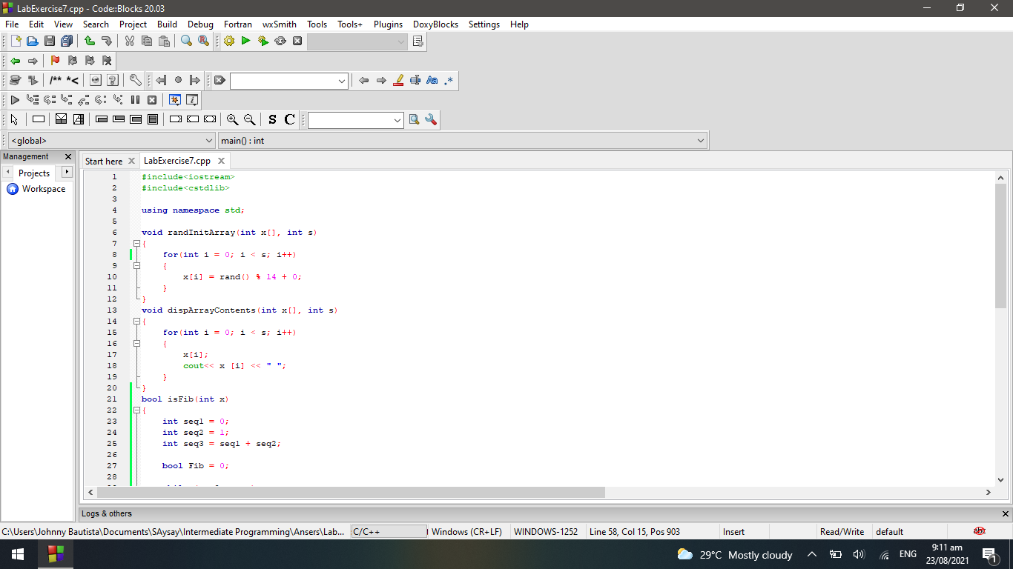

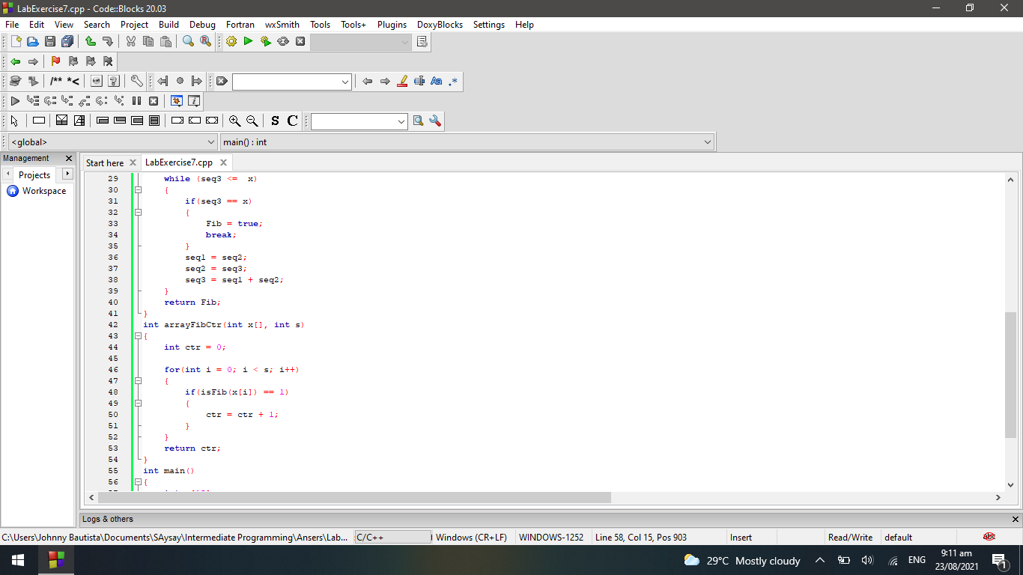

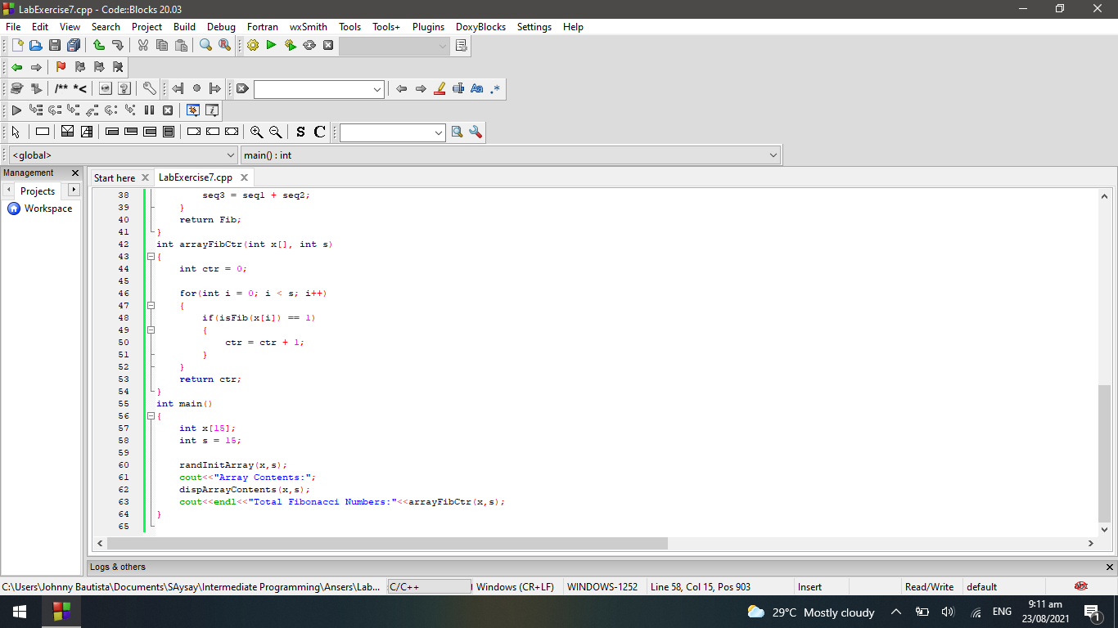

**OUTPUT:**

